Static tests

Static tests involve the examination of the software without the use of software code and documentation as it mainly consists of reviews, setting standards and meetings. In this section developers agree on a set of rules which will be use throughout the development phase (such as documentation and coding standards). Static testing consists of checks which are used to avoid errors in the early stages of development and can usually prevent problems which would have occurred in the later stages of development, as it focuses on avoiding potential defects.

Static testing techniques we used include:

* Informal reviews – in the early stages of development informal reviews are used to inform other members of the team of the state of the development without the need of documentation.

We regularly used informal reviews through Slack as it provided us with a reference point as to how well the team is handling the given tasks.

* Walkthroughs – they are a form of peer review where developers walk each other through the product and ask questions, make comments about its state. It is used to familiarize others with the software.

We mainly used walkthroughs to familiarize each other with the newly written code, and what the though process was behind it.

* Technical reviews – another form of peer review, where developers ensure the technical concepts are understood and implemented correctly

These reviews were mainly used in the beginning and in tandem with teachers to verify if we have correctly understood the requirements, they were really useful as we have received instant feedback.

Static analysis we used

Static analysis is used before and during integration testing to confirm that the predefined guidelines and coding standards are adhered to.

Data Flow – a form of white box testing where its purpose is to reveal mistakes which may result in incorrect implementations and usage of the data variables/values (data anomalies), as the inconsistency can lead to failure.

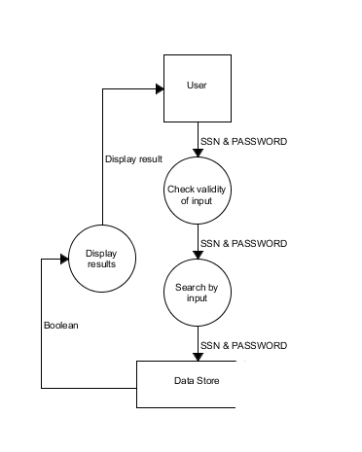

In figure x we show the data flow of logging in to our application.

Control Flow - the sequence in which individual functions, statements or instructions are (or can be) executed in the application.

MISSING FIGURE